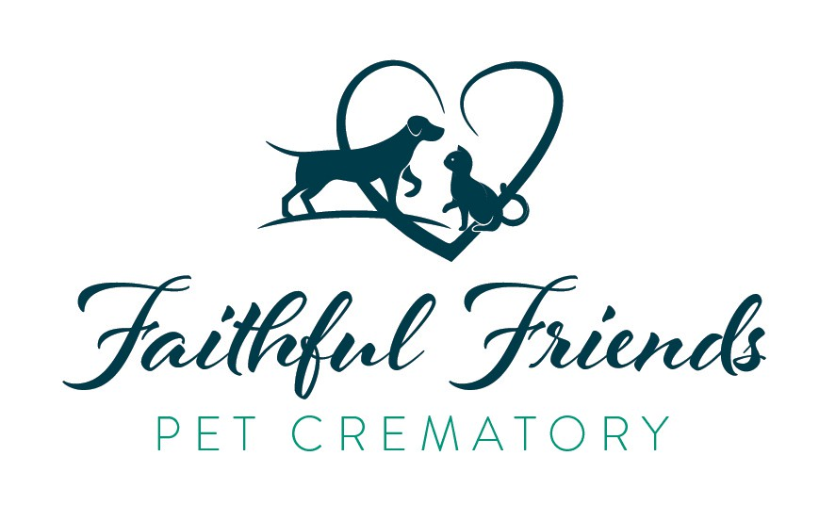
Intake Date:
Date of Cremation: ID#

Pet Release / Authorization for Final Disposition PET INFORMATION
Last Name:
Name of Pet:
Dog: Cat: | Other: | Age: |  | Breed: | Weight: | Male/Female:
Date of Death:
Owner Name: |  |  |  | Address:
City: |  |  | State: |  | Zip:
Phone: |  |  | Cell: |  | Email:

AUTHORIZATION
This authorization form is required to be completed and signed prior to the final disposition of your pet. CREMATION IS AN IRREVERSIBLE AND FINAL PROCESS. It is important that you understand the cremation process and different options available prior to signing it. We want you to fully understand the information provided in this authorization form, so we will be pleased to answer any questions you may have. I/We represent that I/We have the right to authorize the cremation of the pet’s remains and warrant that I/We are the owner or an Agent of the Owner (“Authorizing Agent”). I/We have read and initialed all required Pet Disclosures as listed on the reverse side. I/We have read and understand the description of all the different cremation processes described on the reverse side including the final disposition/return of cremated remains; by initialing below, I/We authorize the following:
Private Cremation; I/We shall receive my pet’s cremated remains. Authorizing Agent
Communal Cremation; I/We shall not receive any cremated remains. Authorizing Agent The crematory shall scatter all remaining cremains.

The Following Urn(s) to hold the cremated remains:
Cremation Price:
Urn:
Memorials/Keepsakes:
INK PRINT FUR LOCK CLAY PRINT OBITUARY
Total:
Method of Payment: | Visa | Mastercard | Cash | Check#

RELEASE AND CERTIFICATION

I/We agree to release and indemnify the Veterinarian, the Funeral Home, the Crematory, their officers, directors, agents and employees, from any claim, liability, cost or expense resulting from their reliance on or performance consistent with the directions, declarations, representations, authorizations and limited to a refund of the cremation fees paid by me/us. I/We warrant that all representations and statements contained in this form are true and correct. I/We have read and understood all pages of this document.

Print Name |  | / | Signature | / | Date
Print Name | / |  | Signature | / | Date

PET DISCLOSURES
I We (initials) further represent and warrant that the animal has not bitten any person or other animal during the past ten (10) days; is not suffering from Rabies, and has not been exposed to other animals suffering from Rabies.

TERMS AND CONDITIONS FOR AUTHORIZATION FORM

CREMATION OPTIONS
Cremation is performed to prepare the remains of the pet for final disposition. It is carried out by placing the pet’s remains into a cremation chamber or retort where they are subjected to intense heat and flame. The cremation can be done in one of three ways, including Private, Partitioned and Communal. A PRIVATE or INDIVIDUAL CREMATION is a cremation procedure during which only one animal’s body is present in the cremation chamber during the cremation process.
A COMMUNAL CREMATION is a procedure where multiple pets are cremated together without any form of separation. These commingled cremated remains are not returned to owners.

CREMATION PROCESS
During the cremation process, it may be necessary to open the cremation chamber and reposition the remains of the animal in order to facilitate a complete and thorough cremation. Through the use of suitable fuel, the incineration of the container and its contents is accomplished and all substances are consumed or driven off, except bone fragments (calcium compounds) metal and other non-combustible materials, as the temperature is not sufficient to consume them. Due to the nature of the cremation process, any possessions or materials, such as collars or tags left with the animal and not removed prior to cremation may be destroyed or if not destroyed will be disposed of by the crematory. The Authorizing Agent understands that arrangements must be made to remove and such personal possessions or materials prior to the time that the animal is transported to the Crematory.
Following a cooling period, the cremated remains shall be recovered by manual means, such as brushing, and industry-specific mechanical means, such as vacuuming, in order to retrieve the cremated remains from the cremation chamber. Although the Crematory will take reasonable efforts to remove all of the cremated remains from the cremation chamber, some dust and other residue from the process will be left behind. However, while every effort will be made to avoid commingling, inadvertent and incidental commingling of minute particles of cremated remains from the residues of previous cremations is possible. The Authorizing Agent understands and accepts that some incidental commingling is possible under any cremation option.

After the cremated remains are removed from the cremation chamber, all non-combustible material (insofar as possible) will be separated and removed from the animal bone fragments by visible or magnetic selection. Other non-bone fragment foreign material recovered with the cremated remains shall be removed prior to processing so that only animal bone fragments will remain. Non-bone fragments and foreign material may be commingled with like material and shall be disposed of in a dignified manner, and in accordance with all applicable laws.
The authorizing Agent understands and authorizes Crematory to dispose of these materials with similar materials from other cremations in non-recoverable manner, including recycling. When cremated remains are removed from the cremation chamber, the skeletal remains often will contain recognizable bone fragments.
Unless otherwise specified, after the bone fragments have been separated from the other material, they will be mechanically processed. The process of crushing or grinding may cause incidental commingling of the remains with the residue from the other processing of previously cremated remains. These granulated particles of unidentifiable dimensions, which are virtually unrecognizable as animal remains, will then be placed into a designated container based on the type of cremation identified above (Private or Communal).

FINAL DISPOSITION OF CREMATED REMAINS
The Authorizing Agent understands that if no arrangements for the final disposition of the cremated remains have been made within sixty (60) days after the cremation or if the Authorizing Agent has not taken delivery of or caused the delivery of the cremated remains, or in the event the arrangement of the final disposition have not been carried out within sixty (60) day period because of the inaction of a party other than the Crematory, Funeral Home, or Veterinarian, THEN the Crematory, Funeral Home, or Veterinarian may dispose of the cremated remains in any dignified manner, including scattering.

THIS AUTHORIZATION FOR CREMATION AND DISPOSITION WAS EXECUDED AT .

THIS , DAY OF 20 .

Crematory Agent Name Crematory Agent Signature

